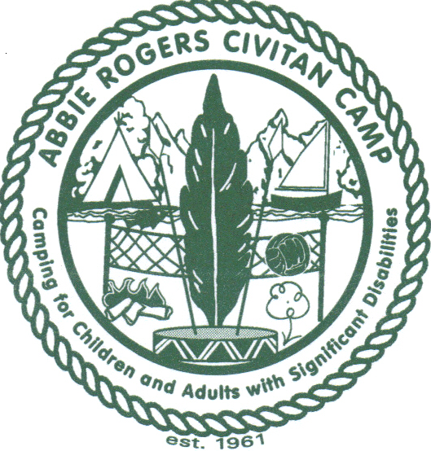
2017 Abbie Rogers Civitan Camp
YOUTH WEEK CHECKLIST
Dear Parents,
This year, the Abbie Rogers Civitan Camp is hosting summer camp centered around the circus, and we are busy planning for THE GREATEST CAMP ON EARTH! Although camp lasts only a week, we work all year long and hope that the memories last until we meet again each summer! Check out our new website at www.AbbieRogersCivitanCamp.org! At the bottom of the HOME PAGE you will see our graphics for this year’s theme and t-shirts, as well as updates about camp. NOTE: IF YOUR CHILD HAS OTHER PLANS THIS SUMMER, WE WILL MISS THEM AND PLEASE CALL OR EMAIL SO WE CAN INVITE SOMEONE ON THE WAITING LIST.
Camp hugs to your family! Our best,
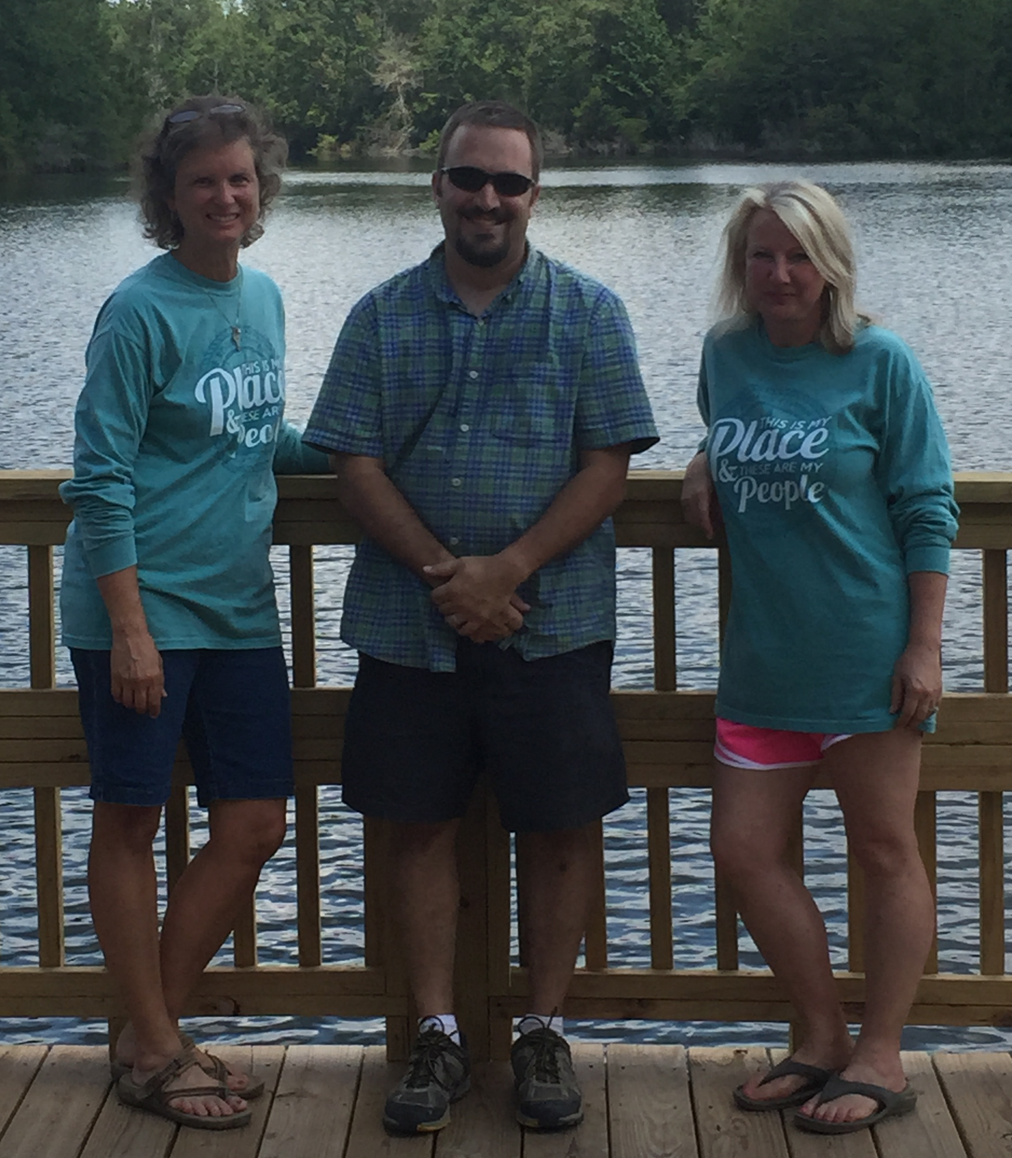
Abbie Rogers Civitan Camp - Youth Session - Camp Iti Kana, Wiggins, MS
Sunday, July 16 (Check In: 2:30-3:30) – Friday, July 21 ( Pick Up: 2:30-3:30)
_____1. Review/Correct/Complete Registration Form 1 and return by April 1st along with $50 deposit—
Confirmation of registration acceptance will be sent to you!
_____2. Have Physician/Nurse Practitioner complete and sign Form 2
_____3. Return Form 2 by June 15th
_____4. Total cost $125 – Pay fee balance of $75 on or before registration
_____5. WRITE NAME on all clothing, linens, luggage and personal items
_____6. SUGGESTED PACKING TIP: Pair shirts/shorts in individual plastic bag
NO TOWELS NEEDED, camp will provide  ___ Sunscreen-continuous spray  ___ Shorts  ___ T-Shirts  ___ Underclothing  ___ 2 or 3 swimsuits  ___ Pajamas  ___ Socks  ___ 2 pair tennis shoes  ___ Shower shoes (flip flops)  ___ Diapers/Swim Diapers | ___ Laundry bag  ___ Old bath cloths  ___ Soap  ___ Shampoo  ___ Toothbrush & paste  ___ Deodorant  ___ Comb/Brush  ___ Medicated powder  ___ Insect repellent  ___ Pillow ( 2 pillow cases) | ___ 2 sets single sheets  ___ Blanket  FEMALES  ___ Sanitary Supplies, if  needed  ___ Swim Cover-up  OPTIONAL ITEMS  ___ Rain Jacket  ___ Mattress Pad  ___ Heat Rash Cream

MAIL forms to HATTIESBURG OFFICE: Abbie Rogers Civitan Camp, 50 Fieldstone, Hattiesburg, MS 39402
Questions: Contact Terri Daniels @ troyd@megagate.com or TEXT 601-447-1649

Abbie Rogers Civitan Camp summer sessions are held at Camp Iti Kana, 11 Iti Kana Road, Wiggins, MS 39577

